Brompton Academy:

Home

Athletics Edition





ASPIRE

Ambitious ● Self-Reliant ● Persevering ● Inquisitive ● Respectful ● Enthusiastic





Contents

**Lesson 1**

Introduction

Household **Hurdles**

Lockdown **Long Jump**

**Lesson 2**

Homemade **High Jump**

Stay At Home **Shot Put**

Social Distancing **Sprinting**

Introduction  
Lesson 1

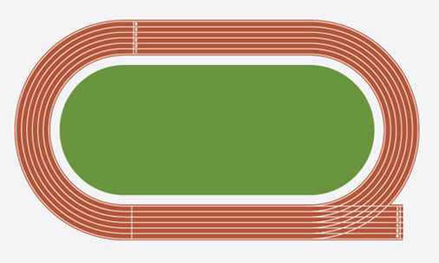[](https://www.google.co.uk/url?sa=i&url=https://www.olympic.org/usain-bolt&psig=AOvVaw31q0Jf4k979t4yktDm1r6U&ust=1587828560378000&source=images&cd=vfe&ved=0CAIQjRxqFwoTCJjVysGwgekCFQAAAAAdAAAAABAD)

**TASK 1**  
Label on the track, where the following events start and finish:

• 100m

• 200m

• 800m

• 1500m

**TASK 2 (SCAN QR CODE)**  
Watch video on **History** of the Olympics and make notes below:

________________________________________________________________________________________________________________________________________________________________

**TASK 3**  
What is your favourite Athletic event and why?

________________________________________________________________________

What are the most important components of fitness for your event? Justify your choice.

____________________________________________________________________________________________________________





[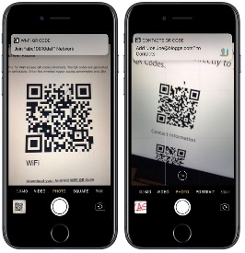](https://www.google.com/url?sa=i&url=https://www.macrumors.com/2017/06/06/iphone-can-scan-qr-codes-ios-11/&psig=AOvVaw23U7hfkSWL31iE670189WT&ust=1588018703388000&source=images&cd=vfe&ved=0CAIQjRxqFwoTCJCw9ev0hukCFQAAAAAdAAAAABAD)

Household Hurdles  
Lesson 1

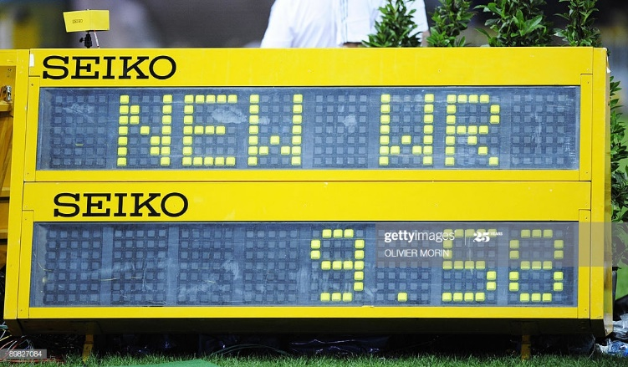

**TASK 4 (SCAN QR CODES)**Watch both World Record videos and write the following:

◻ Athlete Name

◻ Time

◻ Year

◻ Location

◻ Nationality

**ACTIVITY**Be creative and make your own hurdles using household items, see below for Mr Ayles’ example of a hurdle.

Women’s 100m   
World Record

Men’s 110m   
World Record

[](https://www.google.com/url?sa=i&url=https://www.macrumors.com/2017/06/06/iphone-can-scan-qr-codes-ios-11/&psig=AOvVaw23U7hfkSWL31iE670189WT&ust=1588018703388000&source=images&cd=vfe&ved=0CAIQjRxqFwoTCJCw9ev0hukCFQAAAAAdAAAAABAD)

Men’s

Women’s

You have 3 attempts, how many times can you jump over the hurdle in the Male OR Female WR time.

1

2

3

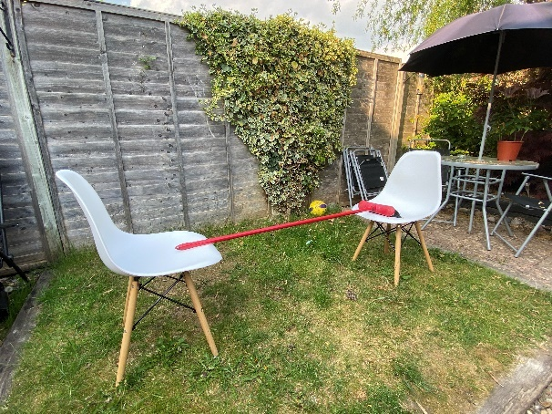

**Boys Girls**

12 11

9 8

6 5



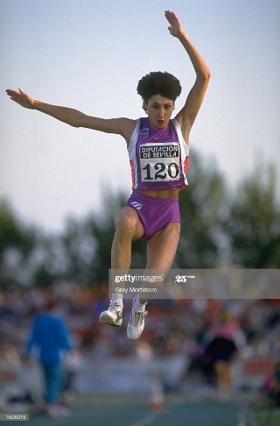

**ACTIVITY**Find a tape measure and set it up anywhere in your house or garden

(as seen below in the photo)

Women’s   
World Record

Men’s   
World Record

Lockdown Long Jump  
Lesson 1

**TASK 5 (SCAN QR CODES)**Watch both World Record videos and write the following:

◻ Athlete Name

◻ Distance

◻ Year

◻ Location

◻ Nationality

[](https://www.google.com/url?sa=i&url=https://www.macrumors.com/2017/06/06/iphone-can-scan-qr-codes-ios-11/&psig=AOvVaw23U7hfkSWL31iE670189WT&ust=1588018703388000&source=images&cd=vfe&ved=0CAIQjRxqFwoTCJCw9ev0hukCFQAAAAAdAAAAABAD)

Men’s

Women’s

You have 3 attempts, how far can you perform a STANDING broad jump, note the score and see if all three of your attempts combined are near the Male or Female WR height.

1

2

3

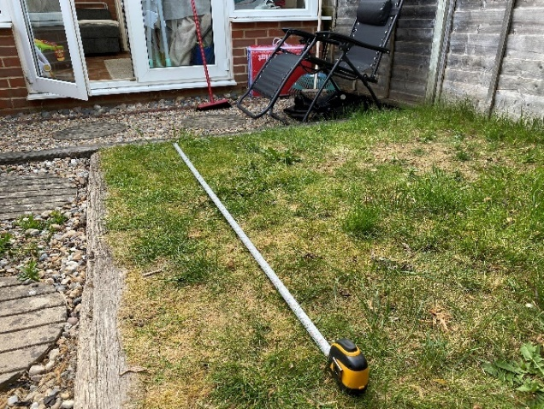

**Boys Girls**

6m 5.5m

5m 4.5m

4.5m 3.5m



Homemade High Jump  
Lesson 2



**TASK 6 (SCAN QR CODES)**Watch both World Record videos and write the following:

◻ Athlete Name

◻ Height

◻ Year

◻ Location

◻ Nationality

Men’s   
World Record

Women’s   
World Record

**ACTIVITY**Watch video below of how to set up and perform your Vertical Jump

If you cannot print the sheet you can improvise and use sticky tape and measure it that way

[](https://www.google.com/url?sa=i&url=https://www.macrumors.com/2017/06/06/iphone-can-scan-qr-codes-ios-11/&psig=AOvVaw23U7hfkSWL31iE670189WT&ust=1588018703388000&source=images&cd=vfe&ved=0CAIQjRxqFwoTCJCw9ev0hukCFQAAAAAdAAAAABAD)

Men’s

Women’s

You have 3 attempts to complete this, note the score and select your best score + your height and see how near you are to Male or Female WR height.

1

2

3



**VIDEO**

Instructions

WATCH ME

**PRINTABLE**

Vertical Jump Sheet

**Boys Girls**

2.2m 2m

1.7m 1.5m

1.2m 1m



Stay At Home Shot Put

Lesson 2

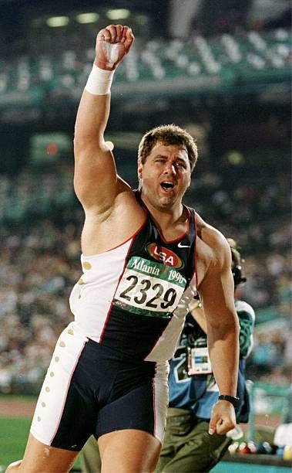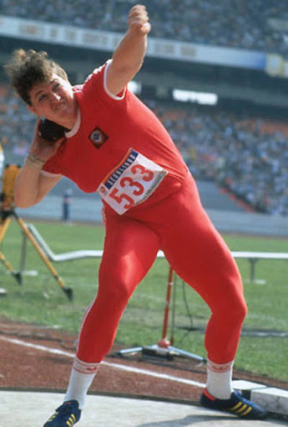

**TASK 7 (SCAN QR CODES)**Watch both World Record videos and write the following:

◻ Athlete Name

◻ Distance

◻ Year

◻ Location

◻ Nationality

Men’s

Women’s

Women’s   
World Record

Men’s   
World Record

[](https://www.google.com/url?sa=i&url=https://www.macrumors.com/2017/06/06/iphone-can-scan-qr-codes-ios-11/&psig=AOvVaw23U7hfkSWL31iE670189WT&ust=1588018703388000&source=images&cd=vfe&ved=0CAIQjRxqFwoTCJCw9ev0hukCFQAAAAAdAAAAABAD)

**ACTIVITY**

Place a target in the garden e.g. a box, a hoop etc. and throw the ball into the target using the technique of a shot put. You can use socks, tennis ball or football to make the shot.

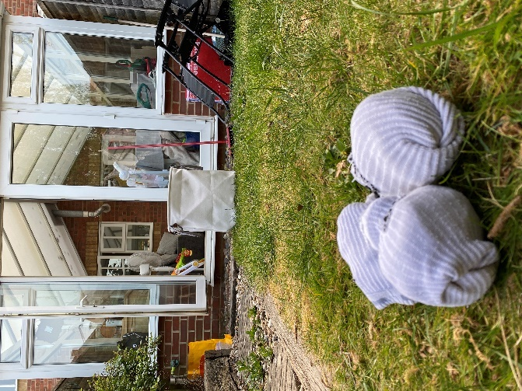

**Boys Girls**

6m 5.5m

5m 4.5m

3.5m 3m

Start with the target being 3m away, if this too easy then increase the distance each time, how far can you put the shot and still make it into the target using the technique below?

Distance ________



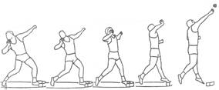

[](https://www.google.com/url?sa=i&url=https://www.macrumors.com/2017/06/06/iphone-can-scan-qr-codes-ios-11/&psig=AOvVaw23U7hfkSWL31iE670189WT&ust=1588018703388000&source=images&cd=vfe&ved=0CAIQjRxqFwoTCJCw9ev0hukCFQAAAAAdAAAAABAD)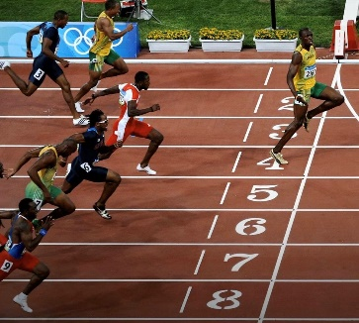

**Boys Girls**

1 min 1 min 5s

1 min 10s 1 min 15s

1 min 20s 1 min 25s



Complete 10 sets and record your time you get

There and back = 1 set.

Time:_______________

**TASK 8 (SCAN QR CODES)**Watch both World Record videos and write the following:

◻ Athlete Name

◻ Time

◻ Year

◻ Location

◻ Nationality

Women’s

Men’s

Social Distancing Sprinting

Lesson 2

Men’s 100m  
World Record

Women’s 100m  
World Record

**ACTIVITY**

Set up cones or a household item that won’t blow away, set them 5m apart.